Dear support,
Please is possible to find in the spreadsheet total sum of opened orders?
If I have opened two stop orders (short and long) the spreadsheet is not showing anywhere:
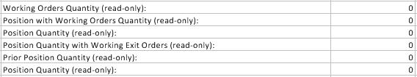
I know, that if I have opened only one stop order I can see it in the field “J3” but short + long with a same qty will make “0” in this field.

I see that fields “J5, J8 – Position Quantity” has the same function, please is possible to change one of the field to counting total sum of quantity with opened orders? (In my case 1+1 = 2)

Thank you

