Sierra charts vs IB ES

Same month but Sierra charts does not look the same as Interactive brokers ( where the data is coming from or Esignal??
sierra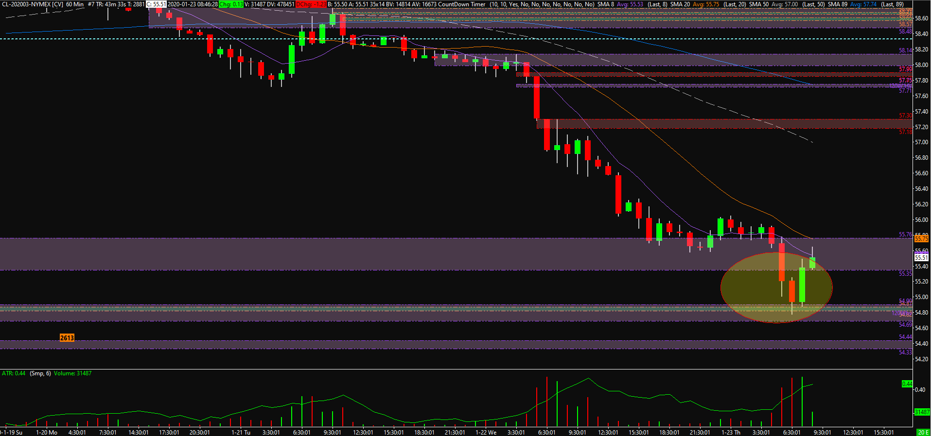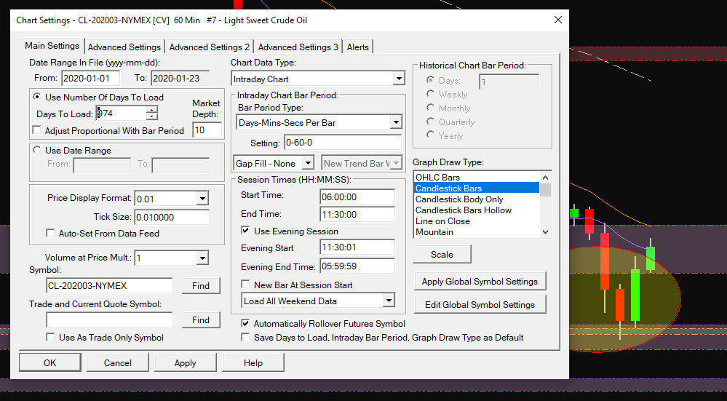
interactive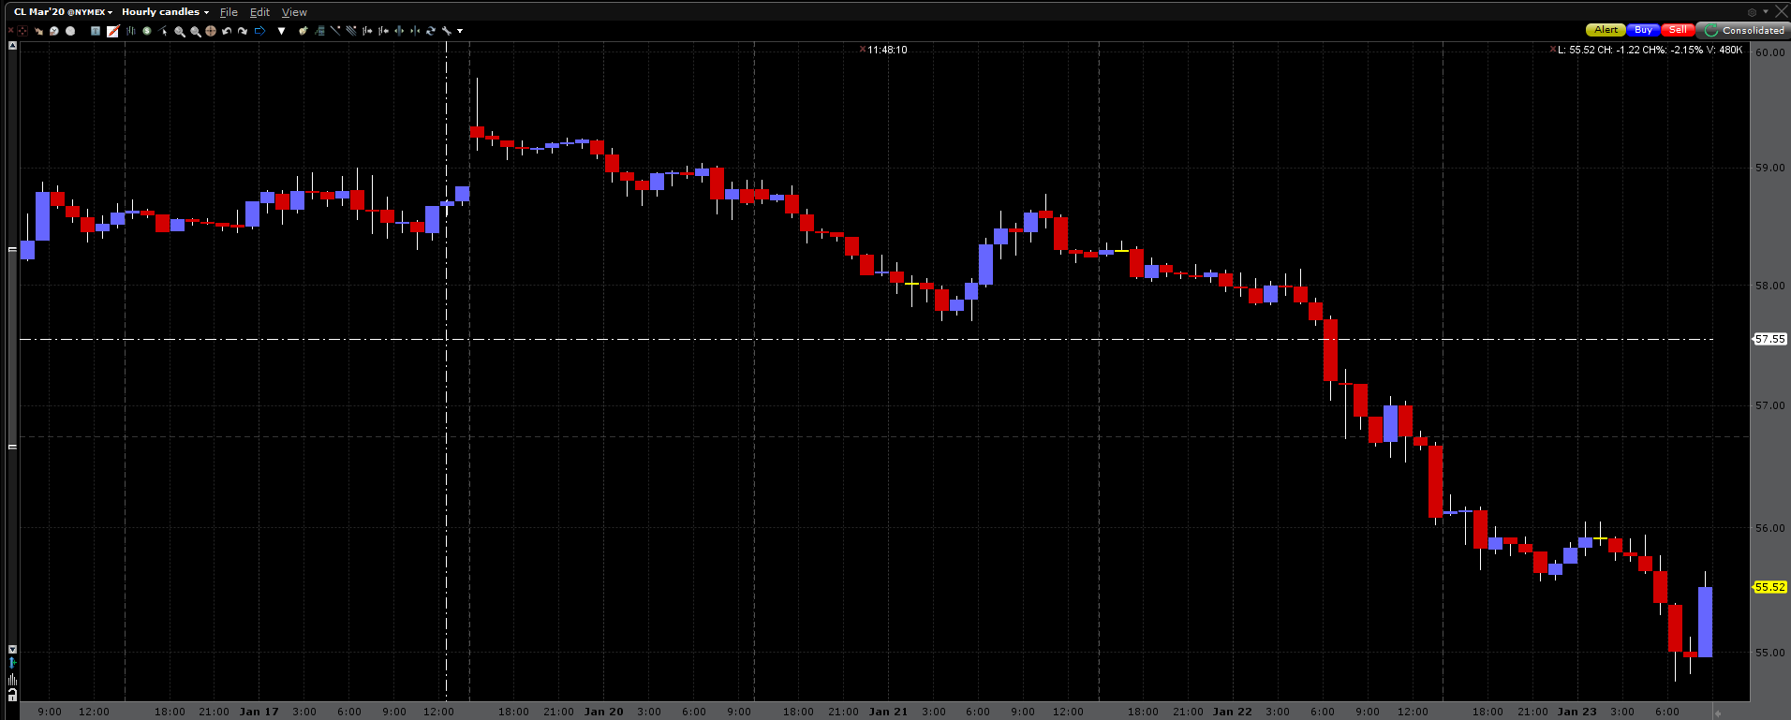
Esignal