SYSTEM | Moving Avarages Crossover system  Reversal and trend following
CHART | 0,5rng Candlestick OHLC
Studies | a. Moving avarage HULL (7)  b. Moving avarage Weighted (30)
Order types | MARKET
Buy Entry | =CROSSFROMBELOW(a;b) | =CROSSFROMBELOW(FY3:FY5;GA3:GA5)
Buy Exit (Sell) | =CROSSFROMabove(a;b) | =CROSSFROMabove(FY3:FY5;GA3:GA5)
Sell Entry | =CROSSFROMabove(a;b) | =CROSSFROMabove(FY3:FY5;GA3:GA5)
Sell Exit (Buy) | =CROSSFROMBELOW(a;b) | =CROSSFROMBELOW(FY3:FY5;GA3:GA5)
 | 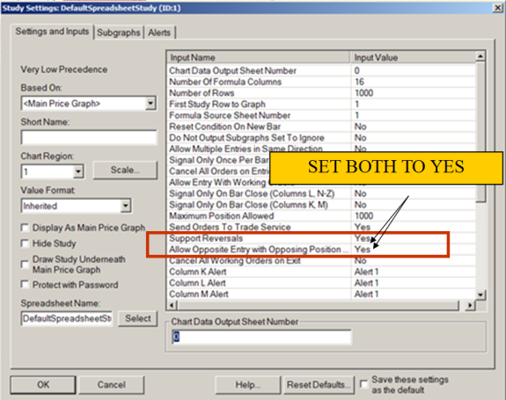 | 