I wanted to join together few months of NG data and test it by Replay Back test.

So I did following steps:

- Export of intraday data to .txt files (months N2-J3)

- Edit of .txt files (I deleted days with low volume on the beginning and at the end inside the datafile)

For example:
datafile NGN2.txt is starting with a date “05.20.2012” and is ending with “06.22.2012”
NGQ2.txt is starting with a date “06.24.2012” and is ending with “07.20.2012”
…
NGJ3.txt is starting with a date “02.24.2013” and is ending with “03.18.2013”

- Join datafiles together into one big file:

Example of lines in joint datafile (name:NG_N2-J3.txt):

Date, Time, Open, High, Low, Last, Volume, Number of Trades, Bid Volume, Ask Volume
05/20/2012, 22:00:03, 2.822, 2.822, 2.806, 2.806, 195, 24, 5, 190
05/20/2012, 22:00:04, 2.805, 2.813, 2.805, 2.813, 17, 7, 0, 17
…
06/22/2012, 21:14:40, 2.641, 2.641, 2.640, 2.640, 3, 3, 2, 1
06/24/2012, 22:00:00, 2.707, 2.709, 2.707, 2.709, 32, 18, 13, 19
…
07/20/2012, 21:14:45, 3.094, 3.094, 3.094, 3.094, 1, 1, 0, 1
07/20/2012, 21:14:53, 3.092, 3.092, 3.092, 3.092, 1, 1, 1, 0
…
…
…
03/18/2013, 19:24:29, 3.868, 3.868, 3.868, 3.868, 1, 1, 0, 1
03/18/2013, 19:26:22, 3.867, 3.867, 3.867, 3.867, 1, 1, 1, 0

- Import file NG_N2-J3.txt to Sierra Chart and the chart was open in the sheet with the same name, see bellow.
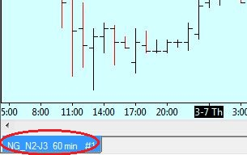

- Copy of the symbol setting:

NG?# setting: NG_N2-J3 setting:
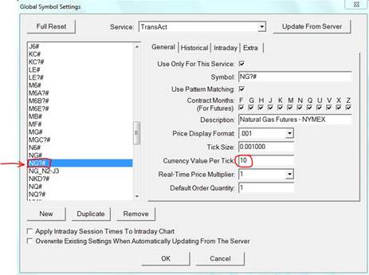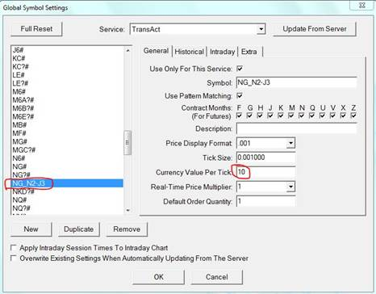

- Open and run Spreadsheet study:

You can see on the screenshots that the spreadsheet with standard symbol is working fine:

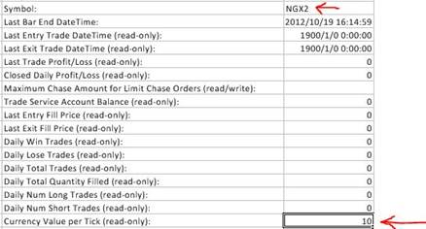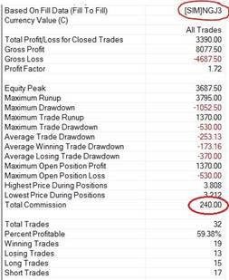
Tick Value in column “J” in the spreadsheet NG?# is 10 trade activity log NG?# is normally calculating include the commission
You can see on the screenshots that the spreadsheet with imported symbol is not working good:

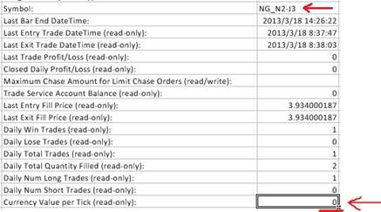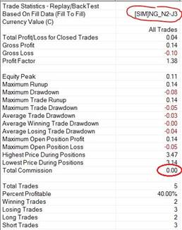
Tick Value in column “J” in the spreadsheet NG_N2-J3 is EMPTY trade activity log NG_N2-J3 is calculating only ticks and without the commission

Please can you help me?

