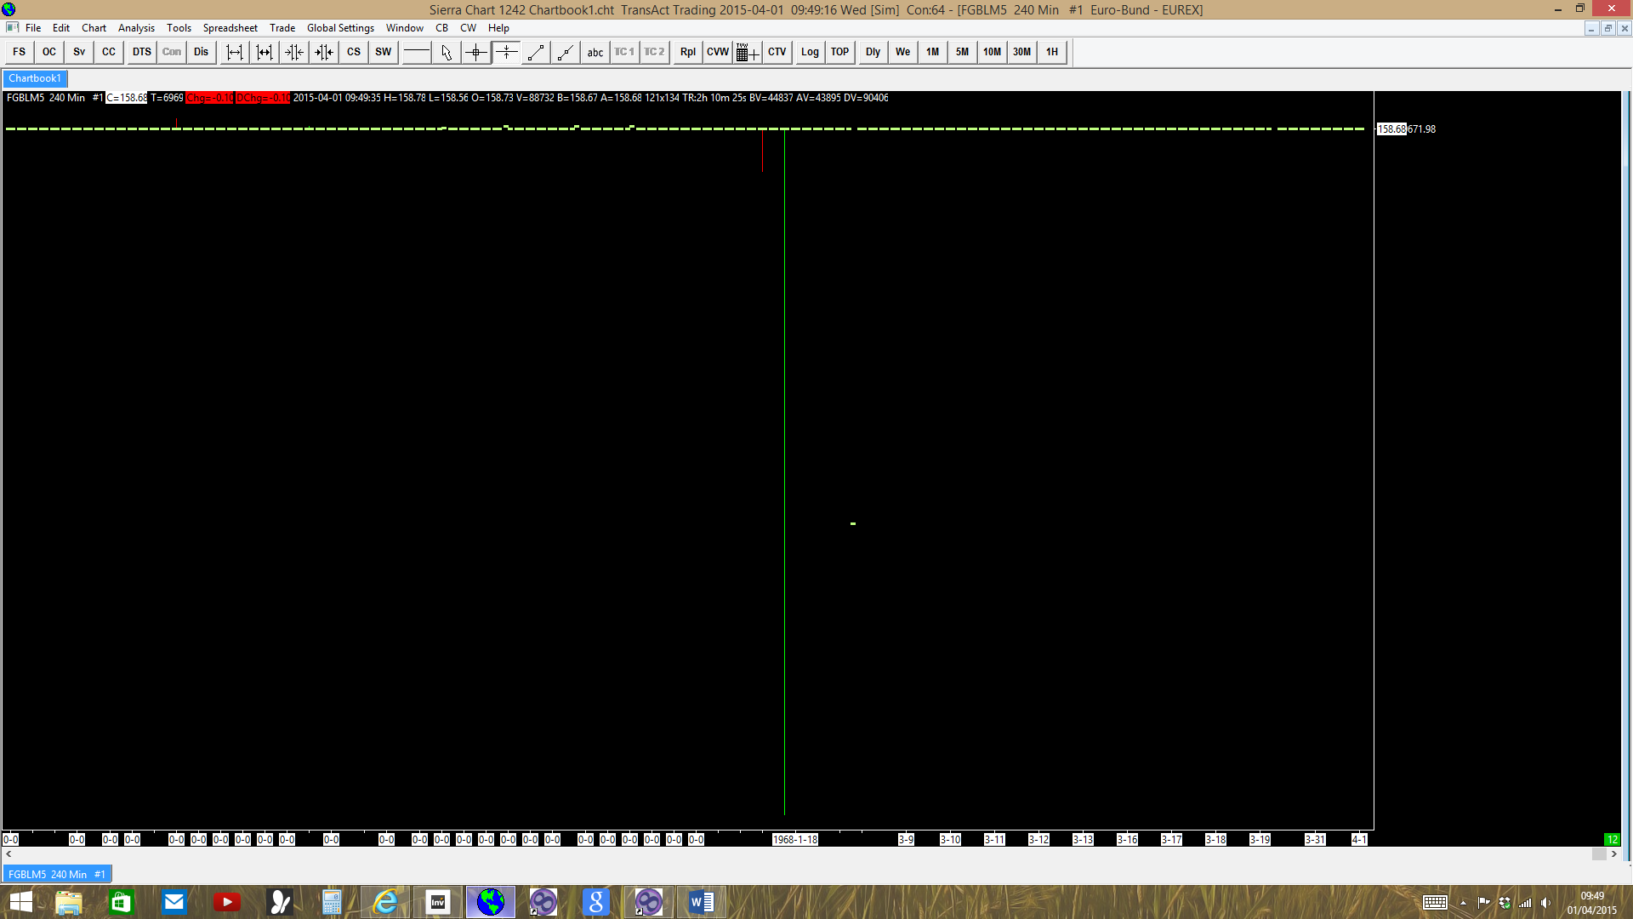Software version: 1242 | 2015-04-01 09:37:44
Uses New Spreadsheets | 2015-04-01 09:37:44
Usage end date: 2015-04-16 | 2015-04-01 09:37:44
Enabled for: Advanced Features. | 2015-04-01 09:37:44
Enabled for: Sierra Chart Historical Data Service. | 2015-04-01 09:37:44
Allow Support for Sierra Chart Data Feeds is enabled. | 2015-04-01 09:37:44
Active service: TransAct Trading | 2015-04-01 09:37:44
Time Zone: +02:00:00 (CET+01CEST+01,M3.5.0/02:00,M10.5.0/03:00) | 2015-04-01 09:37:44
2015-04-01 09:37:44 Local computer clock time | 2015-04-01 09:37:44
2015-04-01 07:37:44 GMT time | 2015-04-01 09:37:44
2015-04-01 09:37:44 Time zone adjusted time | 2015-04-01 09:37:44
Time difference to server time: 27 seconds. | 2015-04-01 09:37:44
Program path: C:\SierraChart\ | 2015-04-01 09:37:44
Data Files path: C:\SierraChart\Data\ | 2015-04-01 09:37:44
OS Version Number: 6.2 | 2015-04-01 09:37:44
Locale Information: C | 2015-04-01 09:37:44

Checking for new symbol settings for ta | 2015-04-01 09:37:44
HTTP connection to www.sierrachart.com:80 (0) | Resolved address sierrachart.com to IP 5.9.8.236 | 2015-04-01 09:37:44
HTTP connection to www.sierrachart.com:80 (1) | Connected. | 2015-04-01 09:37:44
Symbol settings are up-to-date for ta | 2015-04-01 09:37:45

TransAct Trading | Starting server: C:\SierraChart\Transact\TransactToSierraBridge.exe | 2015-04-01 09:37:49
HTTP connection to www.sierrachart.com:80 (1) | Closed. No error. | 2015-04-01 09:37:50
HTTP connection to www.sierrachart.com:80 (1) | Shutdown and closed. | 2015-04-01 09:37:50
TransAct Trading | Connecting to the server 127.0.0.1. Port 80 | 2015-04-01 09:37:51
Socket (2) | Connected. | 2015-04-01 09:37:51
TransAct Trading | Connected to server. | 2015-04-01 09:37:51
TransAct Trading | Sending logon request message. | 2015-04-01 09:37:51
TransAct Trading | Server Name: Transact Futures/TransactToSierraBridge/1.3.5.0. | 2015-04-01 09:37:55
TransAct Trading | Server protocol version: 4. Client protocol version: 5. There is a protocol mismatch! | 2015-04-01 09:37:55
TransAct Trading | Successfully connected. Operation Successful. | 2015-04-01 09:37:55
TransAct Trading | Starting real-time market data updates for: FGBLM5. ID: 1 | 2015-04-01 09:47:58
Intraday data recording state for symbol FGBLM5 is set to download pending. | 2015-04-01 09:47:58
HD Request # 2 | Downloading Intraday chart data for FGBLM5 to the file FGBLM5.scid. Service: ta | 2015-04-01 09:47:58
HD Request # 2 | Download start Date-Time: 2015-03-31 20:59:38.0 | 2015-04-01 09:47:58
HD Request # 2 | Using server: ds5.sierracharts.com port 10149 | 2015-04-01 09:47:58
Socket (0) | Resolved address ds5.sierracharts.com to IP 204.15.192.106 | 2015-04-01 09:47:58
Socket (3) | Connected. | 2015-04-01 09:47:58
HD Request # 2 | Sending historical data logon request message. | 2015-04-01 09:47:58
FGBLM5 1 Min #1 | Out of order timestamps detected. Chart tool drawings and some chart studies may not function properly. Prior Date Time: 2015-03-05 17:49:00. Next Bar Date Time: 0-00-00 00:00:00. Filename: FGBLM5.scid | 2015-04-01 09:47:58
FGBLM5 1 Min #1 | Out of order timestamps detected. Chart tool drawings and some chart studies may not function properly. Prior Date Time: 0-00-00 00:00:00. Next Bar Date Time: 0-00-00 00:00:00. Filename: FGBLM5.scid | 2015-04-01 09:47:58
FGBLM5 1 Min #1 | Out of order timestamps detected. Chart tool drawings and some chart studies may not function properly. Prior Date Time: 0-00-00 00:00:00. Next Bar Date Time: 0-00-00 00:00:00. Filename: FGBLM5.scid | 2015-04-01 09:47:58
FGBLM5 1 Min #1 | Out of order timestamps detected. Chart tool drawings and some chart studies may not function properly. Prior Date Time: 0-00-00 00:00:00. Next Bar Date Time: 0-00-00 00:00:00. Filename: FGBLM5.scid | 2015-04-01 09:47:58
FGBLM5 1 Min #1 | Out of order timestamps detected. Chart tool drawings and some chart studies may not function properly. Prior Date Time: 00:00:00. Next Bar Date Time: 0-00-00 00:00:00. Filename: FGBLM5.scid | 2015-04-01 09:47:58
FGBLM5 1 Min #1 | Out of order timestamps detected. Chart tool drawings and some chart studies may not function properly. Prior Date Time: 0-00-00 00:00:00. Next Bar Date Time: 0-00-00 00:00:00. Filename: FGBLM5.scid | 2015-04-01 09:47:58
FGBLM5 1 Min #1 | Out of order timestamps detected. Chart tool drawings and some chart studies may not function properly. Prior Date Time: 0-00-00 00:00:00. Next Bar Date Time: 0-00-00 00:00:00. Filename: FGBLM5.scid | 2015-04-01 09:47:58
FGBLM5 1 Min #1 | Out of order timestamps detected. Chart tool drawings and some chart studies may not function properly. Prior Date Time: 0-00-00 00:00:00. Next Bar Date Time: 0-00-00 00:00:00. Filename: FGBLM5.scid | 2015-04-01 09:47:58
FGBLM5 1 Min #1 | Out of order timestamps detected. Chart tool drawings and some chart studies may not function properly. Prior Date Time: 0-00-00 00:00:00. Next Bar Date Time: 0-00-00 00:00:00. Filename: FGBLM5.scid | 2015-04-01 09:47:58
FGBLM5 1 Min #1 | Out of order timestamps detected. Chart tool drawings and some chart studies may not function properly. Prior Date Time: 00:00:00. Next Bar Date Time: 0-00-00 00:00:00. Filename: FGBLM5.scid | 2015-04-01 09:47:58
FGBLM5 1 Min #1 | Out of order timestamps detected. Chart tool drawings and some chart studies may not function properly. Prior Date Time: 0-00-00 00:00:00. Next Bar Date Time: 0-00-00 00:00:00. Filename: FGBLM5.scid | 2015-04-01 09:47:58
FGBLM5 1 Min #1 | Out of order timestamps detected. Chart tool drawings and some chart studies may not function properly. Prior Date Time: 0-00-00 00:00:00. Next Bar Date Time: 0-00-00 00:00:00. Filename: FGBLM5.scid | 2015-04-01 09:47:58
FGBLM5 1 Min #1 | Out of order timestamps detected. Chart tool drawings and some chart studies may not function properly. Prior Date Time: 0-00-00 00:00:00. Next Bar Date Time: 0-00-00 00:00:00. Filename: FGBLM5.scid | 2015-04-01 09:47:58
FGBLM5 1 Min #1 | Out of order timestamps detected. Chart tool drawings and some chart studies may not function properly. Prior Date Time: 0-00-00 00:00:00. Next Bar Date Time: 0-00-00 00:00:00. Filename: FGBLM5.scid | 2015-04-01 09:47:58
FGBLM5 1 Min #1 | Out of order timestamps detected. Chart tool drawings and some chart studies may not function properly. Prior Date Time: 0-00-00 00:00:00. Next Bar Date Time: 0-00-00 00:00:00. Filename: FGBLM5.scid | 2015-04-01 09:47:58
FGBLM5 1 Min #1 | Out of order timestamps detected. Chart tool drawings and some chart studies may not function properly. Prior Date Time: 2268-05-29 03:11:00. Next Bar Date Time: 0-00-00 00:00:00. Filename: FGBLM5.scid | 2015-04-01 09:47:58
FGBLM5 1 Min #1 | Out of order timestamps detected. Chart tool drawings and some chart studies may not function properly. Prior Date Time: 00:00:00. Next Bar Date Time: 0-00-00 00:00:00. Filename: FGBLM5.scid | 2015-04-01 09:47:58
FGBLM5 1 Min #1 | Out of order timestamps detected. Chart tool drawings and some chart studies may not function properly. Prior Date Time: 0-00-00 00:00:00. Next Bar Date Time: 0-00-00 00:00:00. Filename: FGBLM5.scid | 2015-04-01 09:47:58
FGBLM5 1 Min #1 | Out of order timestamps detected. Chart tool drawings and some chart studies may not function properly. Prior Date Time: 00:00:00. Next Bar Date Time: 0-00-00 00:00:00. Filename: FGBLM5.scid | 2015-04-01 09:47:58
FGBLM5 1 Min #1 | Out of order timestamps detected. Chart tool drawings and some chart studies may not function properly. Prior Date Time: 0-00-00 00:00:00. Next Bar Date Time: 0-00-00 00:00:00. Filename: FGBLM5.scid | 2015-04-01 09:47:58
HD Request # 2 | Requesting Intraday data. Start Date-Time: 2015-03-31 20:59:38. Record interval: 0. Symbol: FGBLM5 | 2015-04-01 09:47:59
HD Request # 2 | Decompressing data. | 2015-04-01 09:47:59
HD Request # 2 | Receiving Intraday data for FGBLM5 starting at 2015-03-31 20:59:40 | 2015-04-01 09:47:59
HD Request # 2 | Timestamp of first Intraday data file record written: 2015-03-31 20:59:40 | 2015-04-01 09:47:59
Socket (3) | Shutdown and closed. | 2015-04-01 09:47:59
The network socket for historical data has been closed. | 2015-04-01 09:47:59
HD Request # 2 | Received 7195 records from 2015-03-31 20:59:40 to 2015-04-01 09:48:23 (12.8 hours) and wrote 7195 records for FGBLM5 | 2015-04-01 09:47:59
Added 3 Time and Sales records to Intraday data file for FGBLM5 after download. | 2015-04-01 09:47:59
HD Request # 2 | Intraday download COMPLETE for FGBLM5. Completion time: 1s. Unique request ID: 1 | 2015-04-01 09:47:59
Removed historical data download ID 1 | 2015-04-01 09:47:59
Real-time Intraday chart data file updates started for FGBLM5 | 2015-04-01 09:47:59

TransAct Trading | There has been no activity on the network socket. Will reconnect. | 2015-04-01 10:23:45 *
Connection to the external service has been lost. | 2015-04-01 10:23:45
Socket (2) | Shutdown and closed. | 2015-04-01 10:23:45
TransAct Trading | Disconnected from the server. | 2015-04-01 10:23:45
Will reconnect to the server in 2.0 seconds. Select 'File >> Disconnect' to prevent further connection attempts. | 2015-04-01 10:23:50
NOTICE: Detected that the system has resumed from a low-power state. | 2015-04-01 10:23:50 *
Re-connecting to the Data/Trading service. | 2015-04-01 10:23:50
TransAct Trading | Disconnected from the server. | 2015-04-01 10:23:50
Will reconnect to the server in 2.0 seconds. Select 'File >> Disconnect' to prevent further connection attempts. | 2015-04-01 10:23:50

TransAct Trading | Starting server: C:\SierraChart\Transact\TransactToSierraBridge.exe | 2015-04-01 10:23:52
TransAct Trading | Connecting to the server 127.0.0.1. Port 80 | 2015-04-01 10:23:54
Socket (4) | Connected. | 2015-04-01 10:23:54
TransAct Trading | Connected to server. | 2015-04-01 10:23:54
TransAct Trading | Sending logon request message. | 2015-04-01 10:23:54
TransAct Trading | Server Name: Transact Futures/TransactToSierraBridge/1.3.5.0. | 2015-04-01 10:23:57
TransAct Trading | Server protocol version: 4. Client protocol version: 5. There is a protocol mismatch! | 2015-04-01 10:23:57
TransAct Trading | Successfully connected. Operation Successful. | 2015-04-01 10:23:57
TransAct Trading | Starting real-time market data updates for: FGBLM5. ID: 1 | 2015-04-01 10:23:58
Intraday data recording state for symbol FGBLM5 is set to download pending. | 2015-04-01 10:23:58
HD Request # 3 | Downloading Intraday chart data for FGBLM5 to the file FGBLM5.scid. Service: ta | 2015-04-01 10:23:58
HD Request # 3 | Download start Date-Time: 2015-04-01 10:18:48.0 | 2015-04-01 10:23:58
HD Request # 3 | Using server: ds3.sierracharts.com port 10149 | 2015-04-01 10:23:58
Socket (0) | Resolved address ds3.sierracharts.com to IP 65.182.172.164 | 2015-04-01 10:23:58
Socket (5) | Connected. | 2015-04-01 10:23:58
HD Request # 3 | Sending historical data logon request message. | 2015-04-01 10:23:58
HD Request # 3 | Requesting Intraday data. Start Date-Time: 2015-04-01 10:18:48. Record interval: 0. Symbol: FGBLM5 | 2015-04-01 10:23:59
HD Request # 3 | Decompressing data. | 2015-04-01 10:23:59
HD Request # 3 | Receiving Intraday data for FGBLM5 starting at 2015-04-01 10:18:48 | 2015-04-01 10:23:59
HD Request # 3 | Timestamp of first Intraday data file record written: 2015-04-01 10:18:57 | 2015-04-01 10:23:59
Socket (5) | Shutdown and closed. | 2015-04-01 10:23:59
The network socket for historical data has been closed. | 2015-04-01 10:23:59
HD Request # 3 | Received 121 records from 2015-04-01 10:18:48 to 2015-04-01 10:24:16 (5.5 minutes) and wrote 110 records for FGBLM5 | 2015-04-01 10:23:59
HD Request # 3 | Intraday download COMPLETE for FGBLM5. Completion time: 1s. Unique request ID: 2 | 2015-04-01 10:23:59
Removed historical data download ID 2 | 2015-04-01 10:23:59
Real-time Intraday chart data file updates started for FGBLM5 | 2015-04-01 10:23:59

