15 minute chart with daily pivots

http://www.sierrachart.com/image.php?l=1426541580287.png
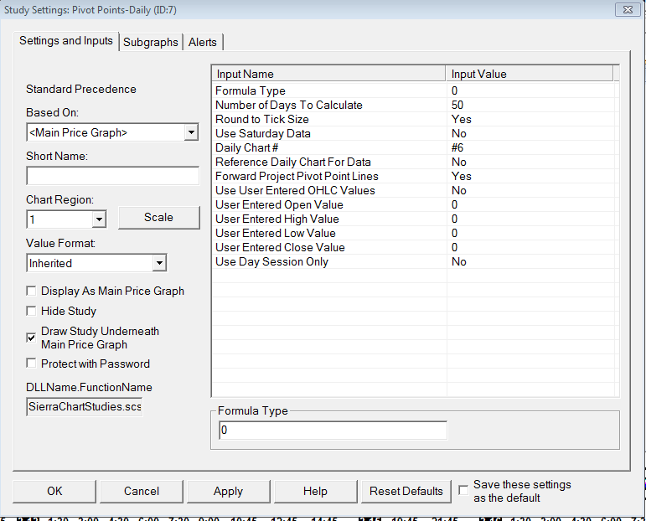

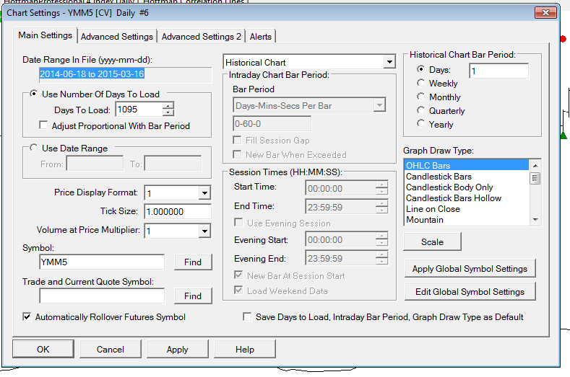

2 minute chart with daily pivots

http://www.sierrachart.com/image.php?l=1426545293178.png
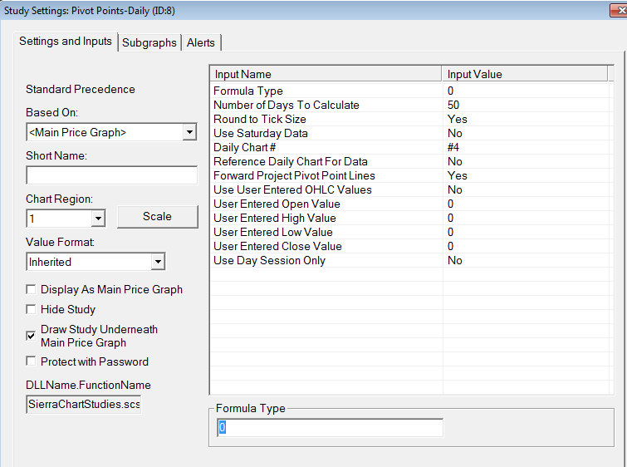

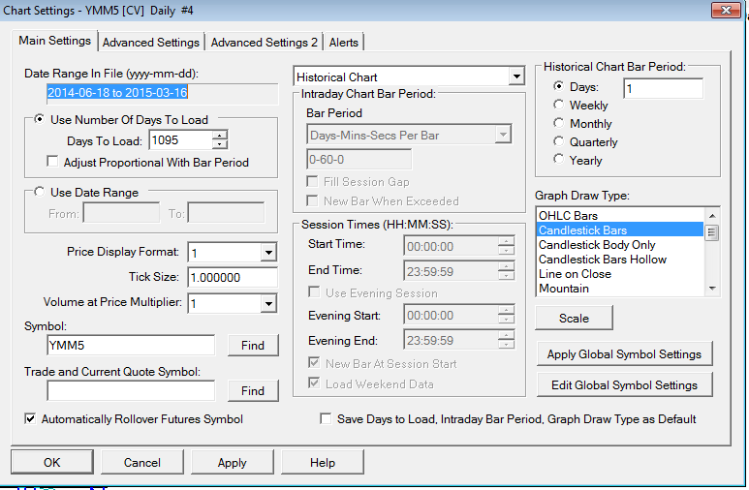

Daily chart #4 referenced by the two minute chart:

http://www.sierrachart.com/image.php?l=14265451631000.png

