Hi Sierra Chart Team
There are invalid values in your server for ^USDINR as shown in the below weekly timeframe.
You are requested to rectify the same so that a valid candle stick chart is visible
Kind Regards
ACCOUNT ID Sandeep N

WEEKLY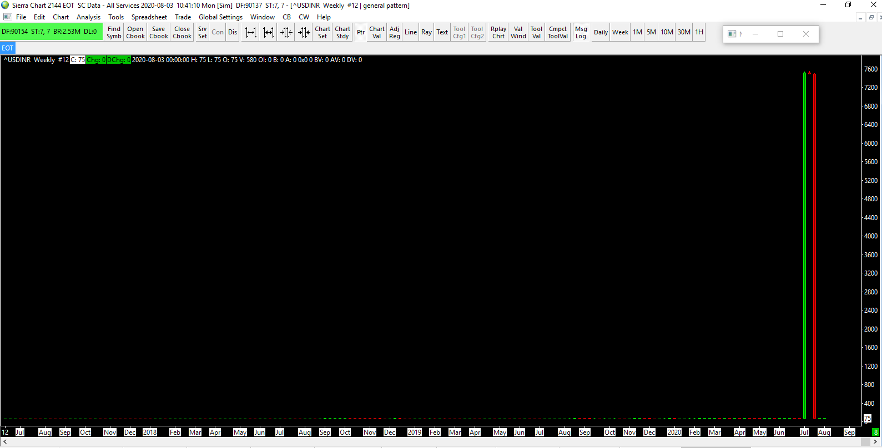
DAILY

