Sierra charts oil 5 min exp
CL Crude oil 5-minute chart June contract.
Sierra charts is printing a different number than other platforms even than interactive brokers where the data is coming from!!!
I have delay in the chart where the countdown timer will stop then jump several seconds sometimes 10-30 seconds, but usually 4 to 5 seconds. Interactive broker the data source is not doing this. My other platforms are not doing this. Even if I run only Interactive and Sierra charts, I still have this problem.
Some are worse than others for example my oil charts only skip 1-4 seconds gold, up to 8 seconds, copper 20 -40 seconds regularly???? As a result my sierra charts end up looking dissimilar to other charts charting platforms.
This is not the computer I have this custom built for my trading business by phoenix trading computers with I7 core full solid state drive and 16g ram . I got 340 MBPS DL speed.
It must be something to do with my Sierra charts platform perhaps a glitch has formed? Is there a way of running a diagnostic or repair tool?
I even reduced worn to a handful of chartbooks and still same problem. I have been using this program for a long time and only recognised this some months ago. I do not think it was present before?
Interactive brokers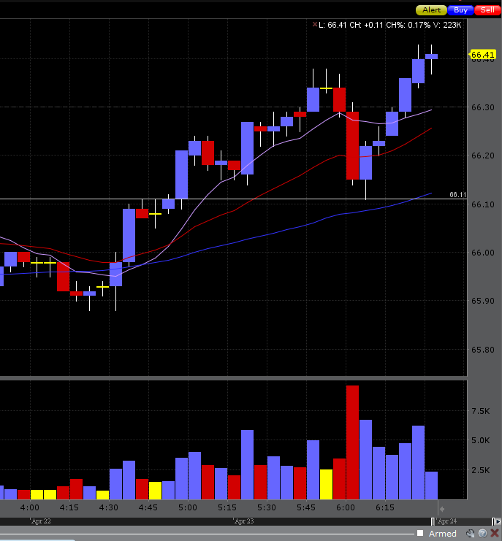
9999999999999999
Sierra charts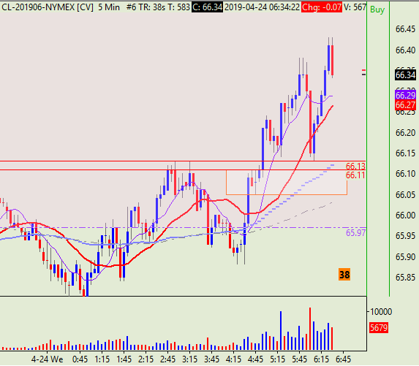
99999999999999999
Tradestation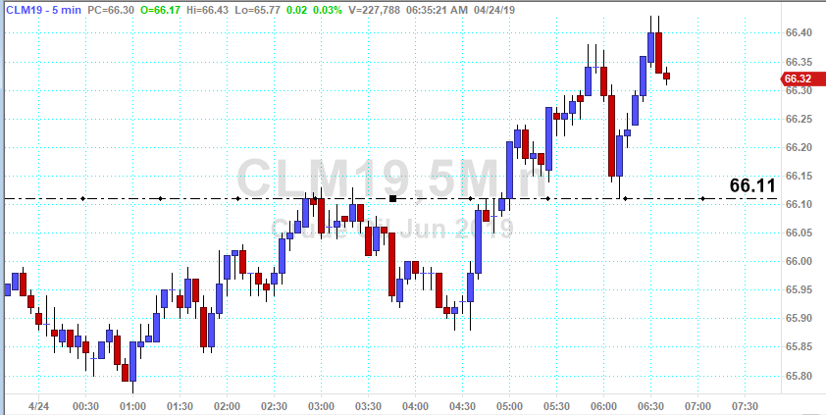
Thinkor swim 

