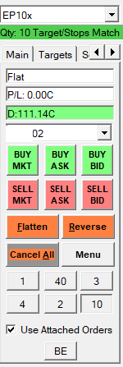
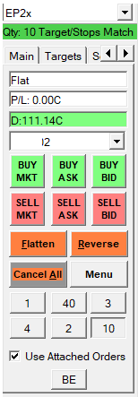
Automatically assign target configuration by chosen quantity of contracts.

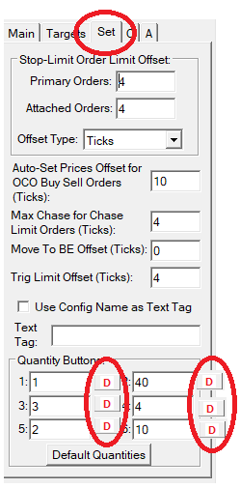
That can be easyly implemented on „TAB SET“, just add extra buttons and one form where will be asign default targets configuration.

