Below are some comparisons of the desired Universal Renko (uni-Renko) vs SC’s uni-Renko chart action for different SC software versions (AT1614 and AT1633). These snips were taken today, 11/2/17, on the ES. A description of the desired operation is also explained in more detail following the snips.

1. Desired vs. SC uni-Renko chart action

Desired vs AT1614 SW version 426 uni-Renko (“426” is the SC uni-Renko setting).

Note the SC chart is almost identical to the desired chart except that the active bar does not start the bar fill from the offset which for these settings should always be the center of the previous bar body.

Desired uni-Renko SC AT1614 426 uni-Renko
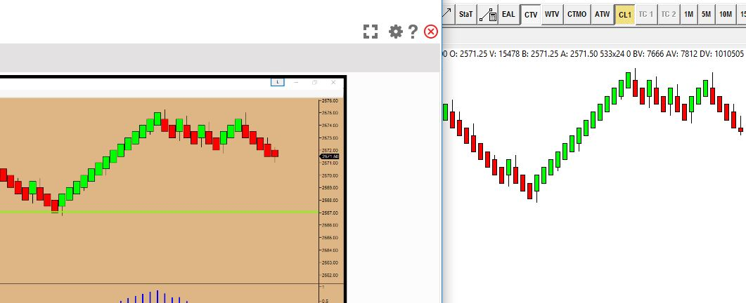

Here’s the same comparison with the same settings using the AT1633 code:
Match is not as good as with the AT1614 code. Candle fill does not always fill from offset – even on completed candles.

Desired uni-Renko SC AT1633 426 uni-Renko
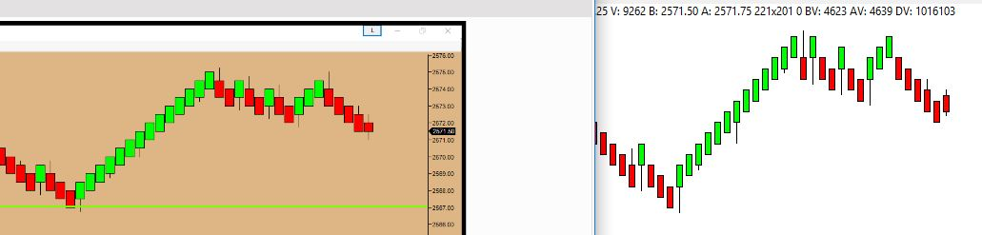

Here’s the same comparison with the same settings using the AT1633 code, but with a 425 uni-Renko setting:
Match is worse than the AT1614 code or AT1633 code with 426 setting.

Desired uni-Renko SC AT1633 425 uni-Renko
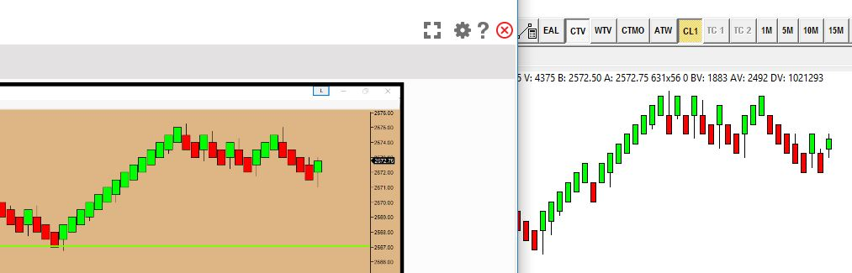

2. Desired universal Renko candle creation and fill action description :
Here’s a description of what the desired operation is. The AT1614 code is close, but just needs different bar fill action.

For candle body size = 4 ticks and offset 2 ticks (relative to candle body high or low), new bar trigger is 5 ticks above or below offset (new offset is 2 ticks below candle body high when trigger is 5 ticks above prev offset; and new offset is 2 ticks above candle body low when trigger is 5 ticks below prev offset)

Note that for these settings, the offset is always at the middle of the 4 tick candle body.

Here’s an example of desired new candle formation and fill action:



